Create & Manage Java objects using Spring Framework

Step-01A: Getting Spring Framework to create & manage our Java Object

In this step let’s get the answer of Our 5th question
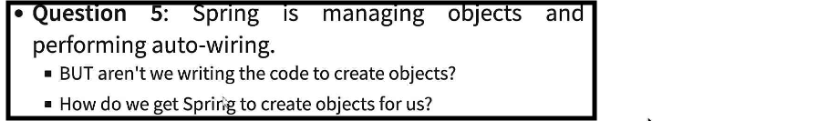

Lets clone the project so that we can compare the code & before accessing the new project we should close our existing project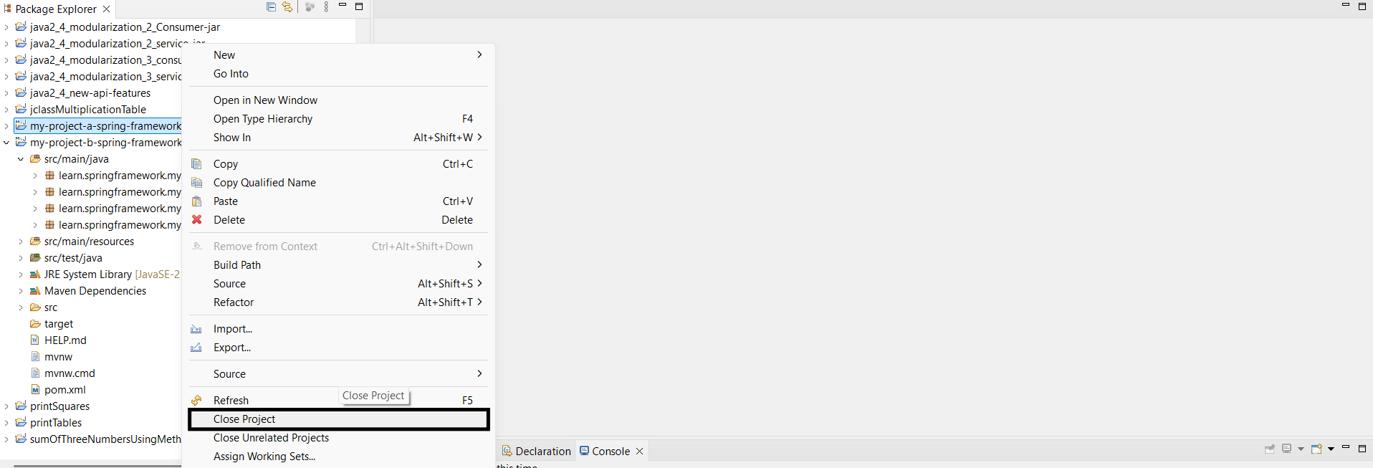

Now let's simplify the code by removing the files which are not required: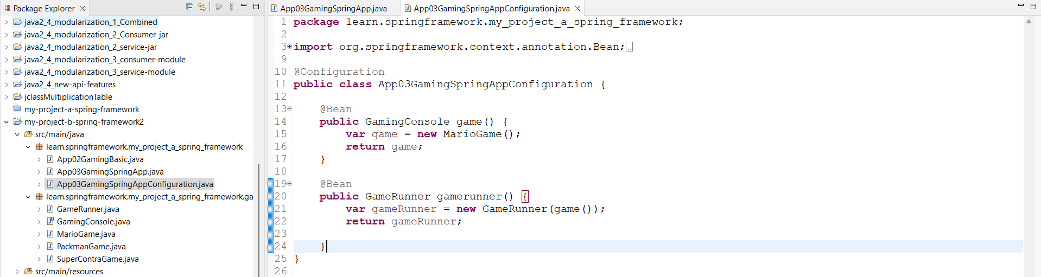

We can remove the Config file & add the class under the Runner class only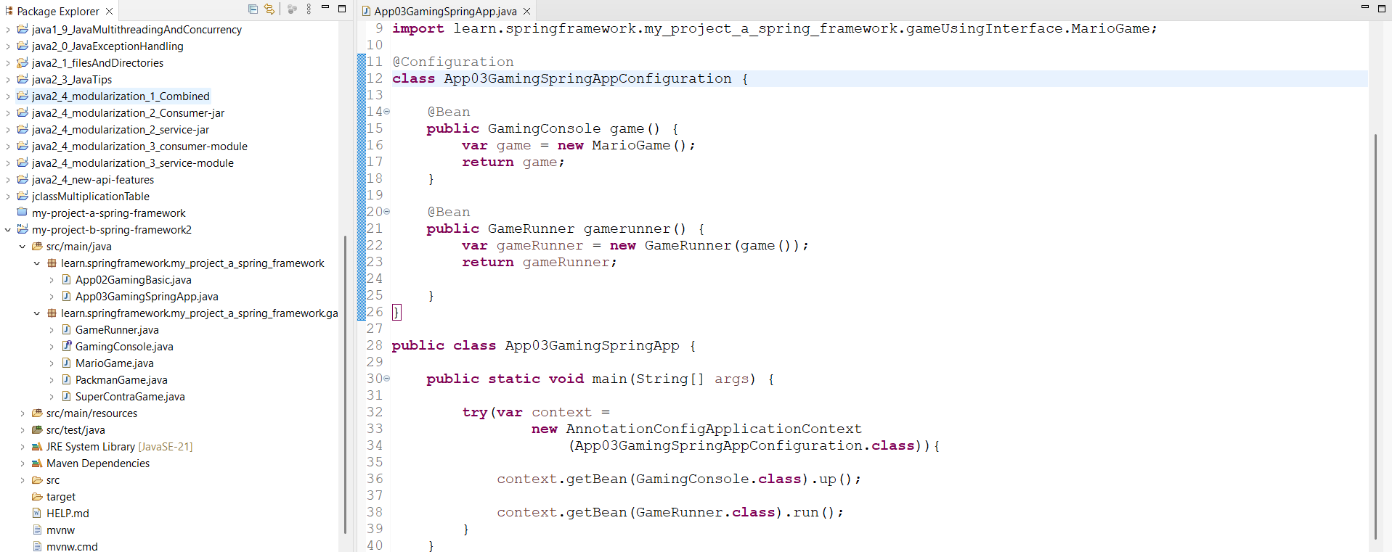

This can be further simplified by moving the Beans under the runner Class & annotating class as ‘Configuration’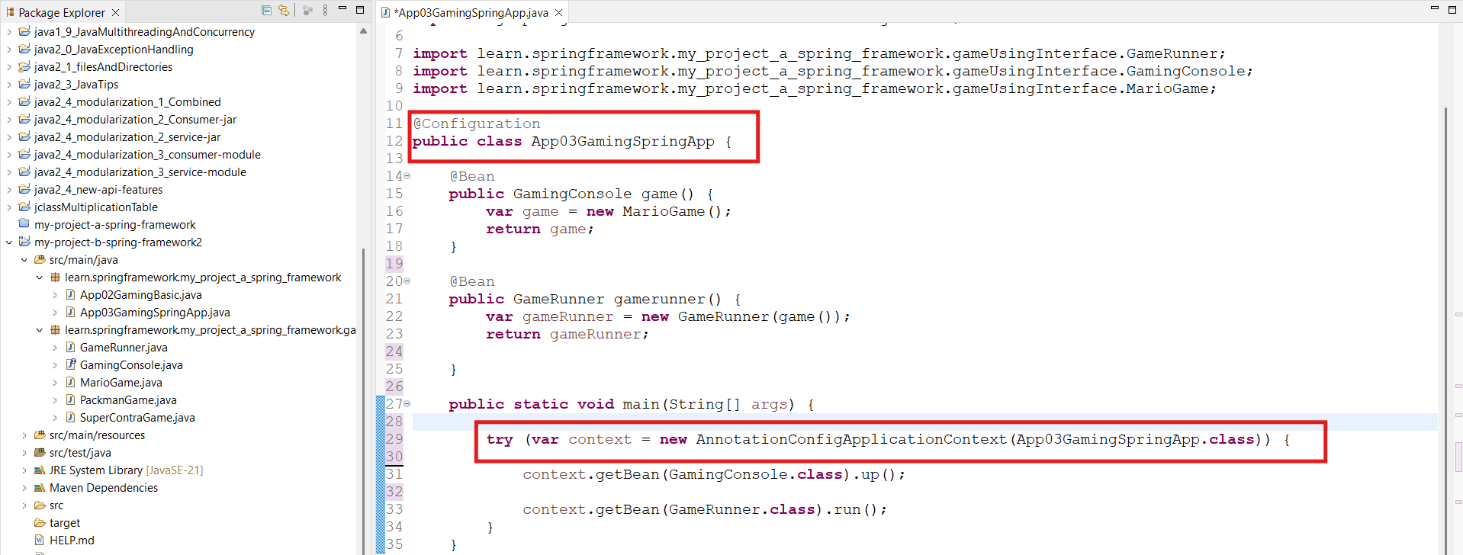

Output: Now if we run the code for above both cases, we will get the same response: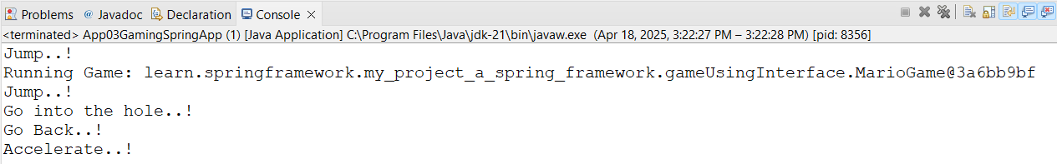

But still we are using ‘@Bean’ Annotation to create the Beans manually.
Let's explore how we can get the Beans created using Spring Framework.

Step-01B: Getting Spring Framework to create Beans using @Component

We can get the Beans created automatically using Spring Framework by using @Component Annotation.

Any Class which will have this annotation, a Bean will be auto-created for the class & will get Auto-Wired.

For Searching the auto-created Beans using @Component, we need to tell the runner where to look for the Bean using @ComponentScan(“packageToBeScanned”) with the Runner/Executing class.

So during Runtime, Spring will create the required Beans for us & OS will scan the specified package to get the Bean & will do Auto-Wiring.

Example: MarioGame class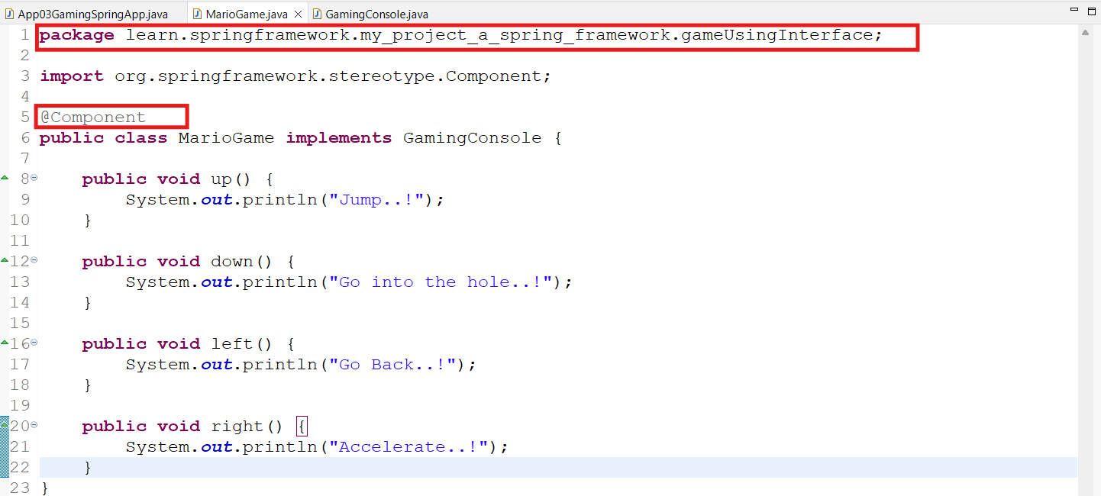

App03GamingSpringAppB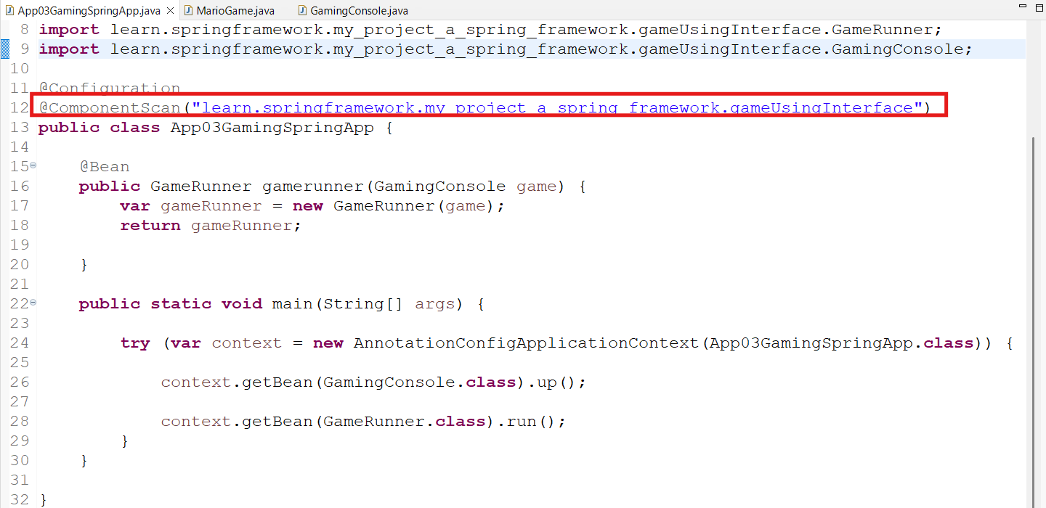
Now if we execute, the same results will be returned:
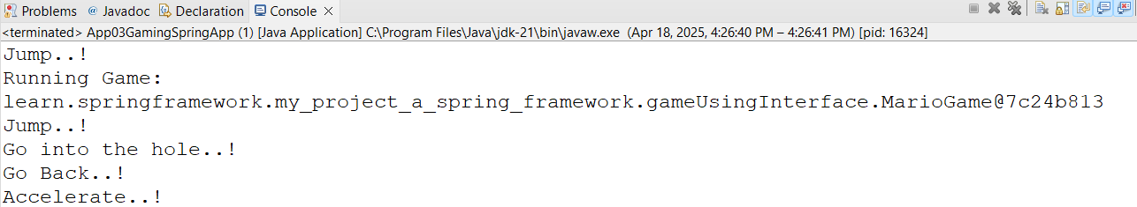

Here we have seen that Bean is created only for MarioGame class & not for the GamingConsole class. We will see it in the next step.

Step-01C: Exercice playing with Spring Framework

GameRunner class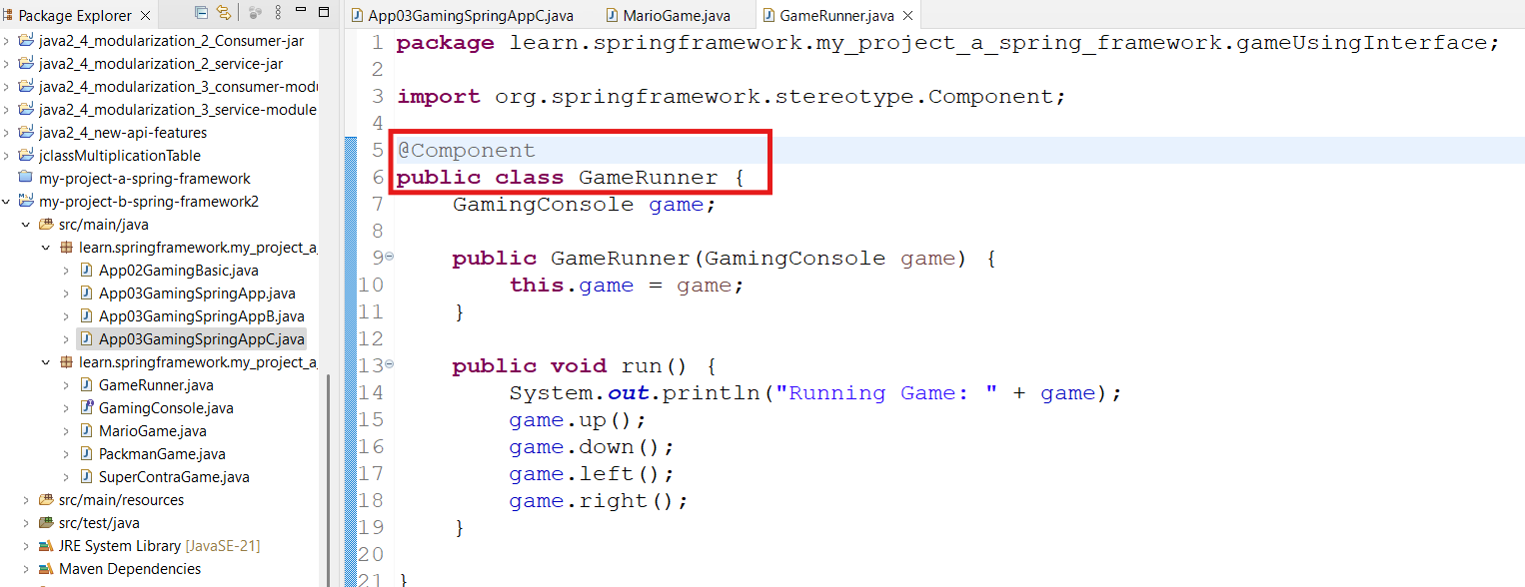

App03GamingSpringAppC: Remove the @Bean & related logic that creates Bean manually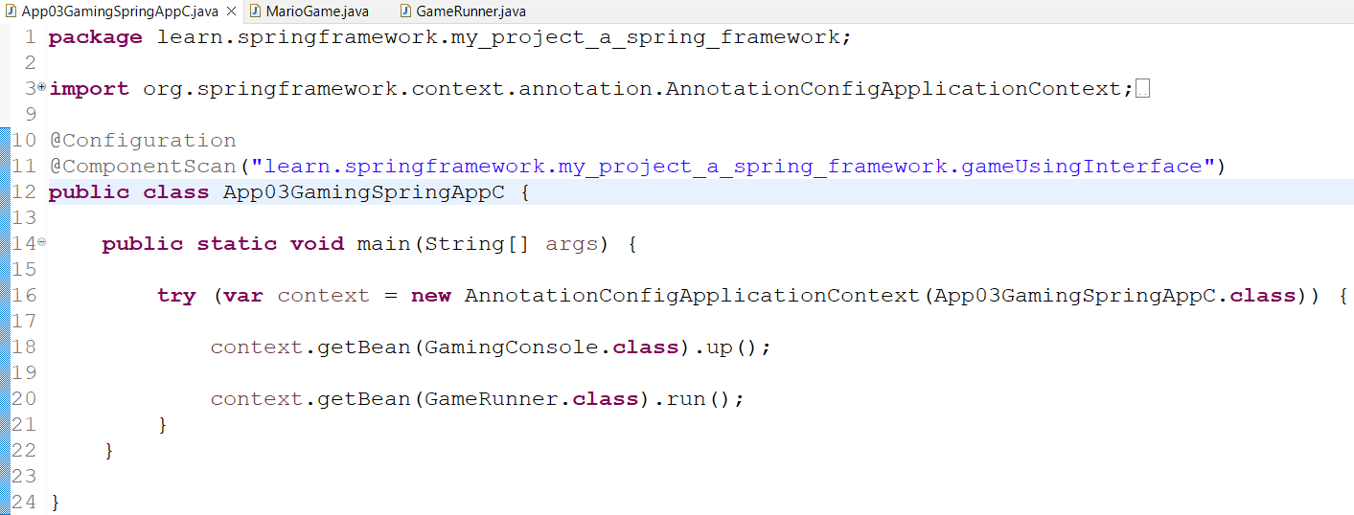

This will also return the same response

Therefore, here, Spring has created Beans automatically for both GameClass as well as GameRunner class.

Step-02: Exploring Primary & Qualifier Annotations for Spring Components

Now let’s create auto-create Beans for other Game classes like PackmanGame & SuperContraGame classes by using @Component Annotation
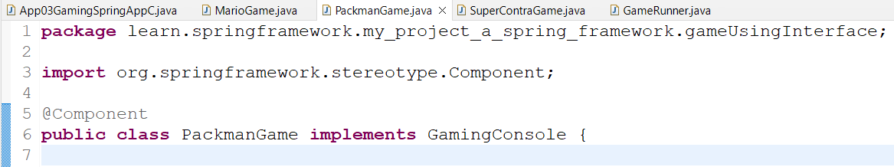

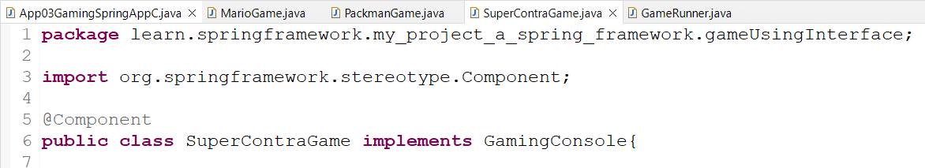

As we can see, there are now 3 Game classes implementing the GamingConsole Interface, so there will be 3 Beans for the GamingConsole.

This will cause an Exception due to non unique GamingConsole Bean while creating Bean for the gameRunner.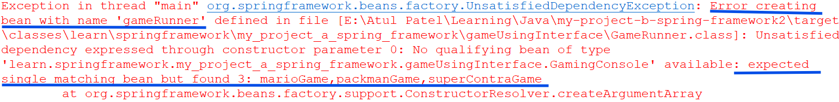

Now to resolve the issue, we use following ways:
- Using @Primary Annotation - Make either of the available Beans as Primary
The Bean which is considered as Primary, will be returned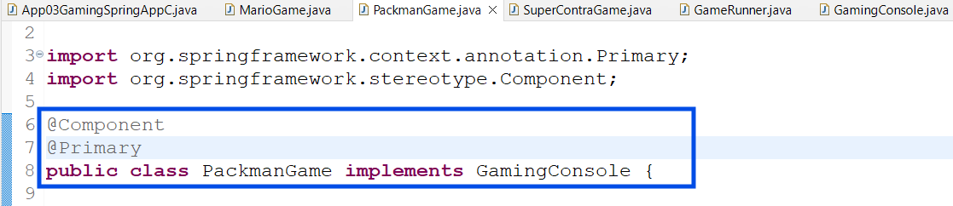

Output: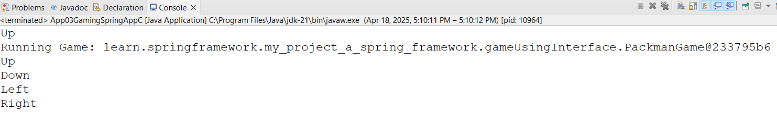

- Using @Qualifier(“Qualifier-name”) Annotation

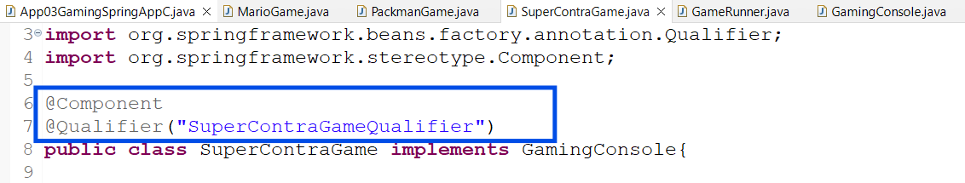

Now In the GameRunner class, Auto-Wiring is happening through the constructor, the GamingConsole instance is getting Auto-Wired to the GameRunner where we can specify the exact Bean for the Game class that needs to be wired.

for example: @Qualifier("SuperContraGameQualifier")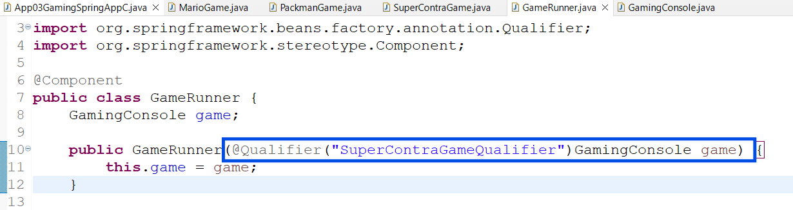
Now we are good to execute the application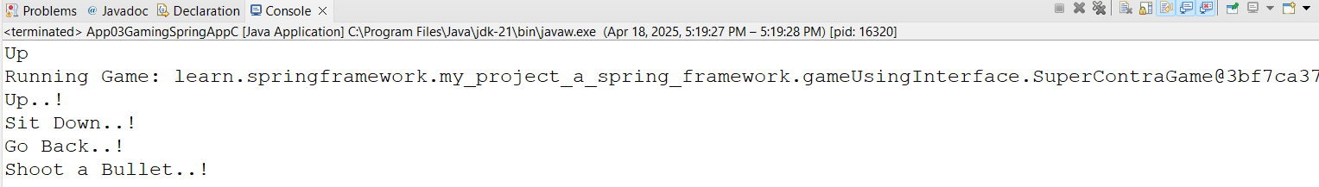
This response is from the SuperContra class.
Step-03: Primary or Qualifier Annotations: Which one should we use?

@Primary: A bean should be given preference when multiple candidates are qualified

@Qualifier:
- A specific Bean should be Auto-Wired(name of the Bean can be used as Qualifier).
- It has a higher priority than @Primary.

Step-04A: Exploring Spring Framework: Different types of Dependency

There are 3 types of Dependency Injections present:
- Constructor Based
Dependencies are set by creating the Bean using its Constructor.

- Setter-Based
Dependencies are set by calling setter methods on the beans

- Field Based
No setter or constructor, Dependency is injected using Reflection

Step-04B: Getting started with Field Injection
The Beans or the objects are identified & wired using Object fields of the Class Type: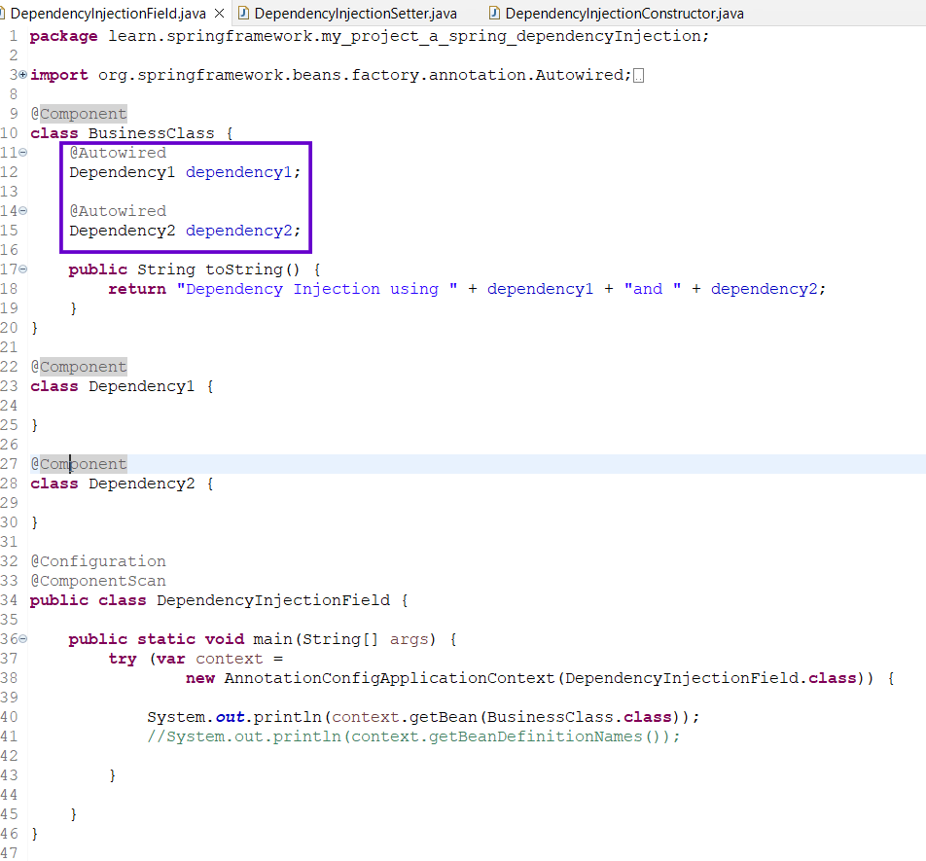

Step-04C: Exploring Setter & Constructor Injection

Dependency Injection using Setters
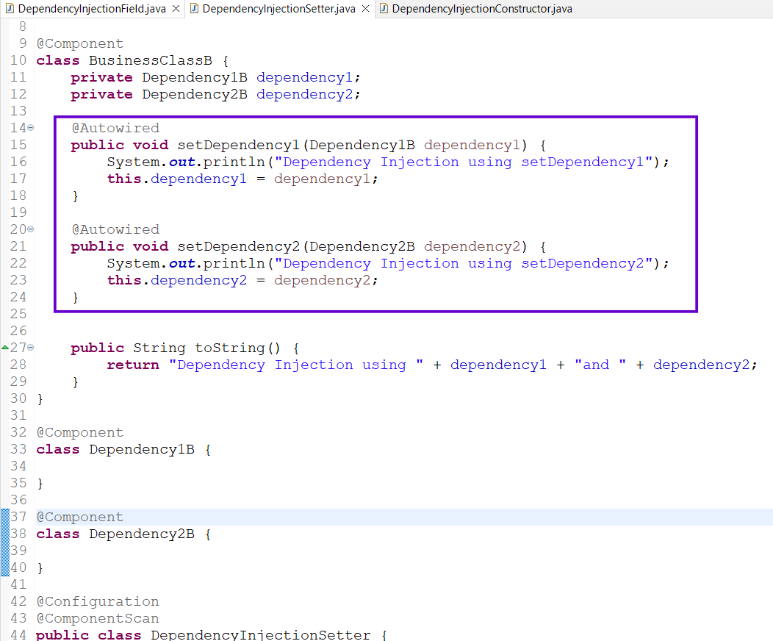
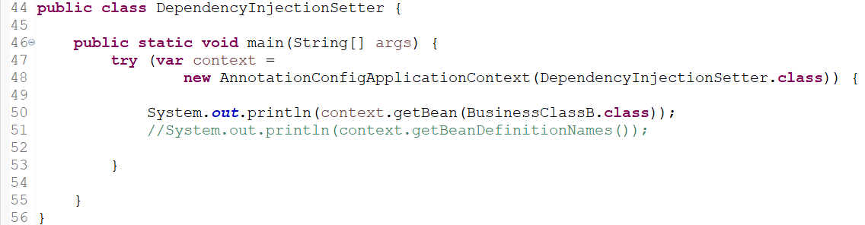

Dependency Injection using Constructors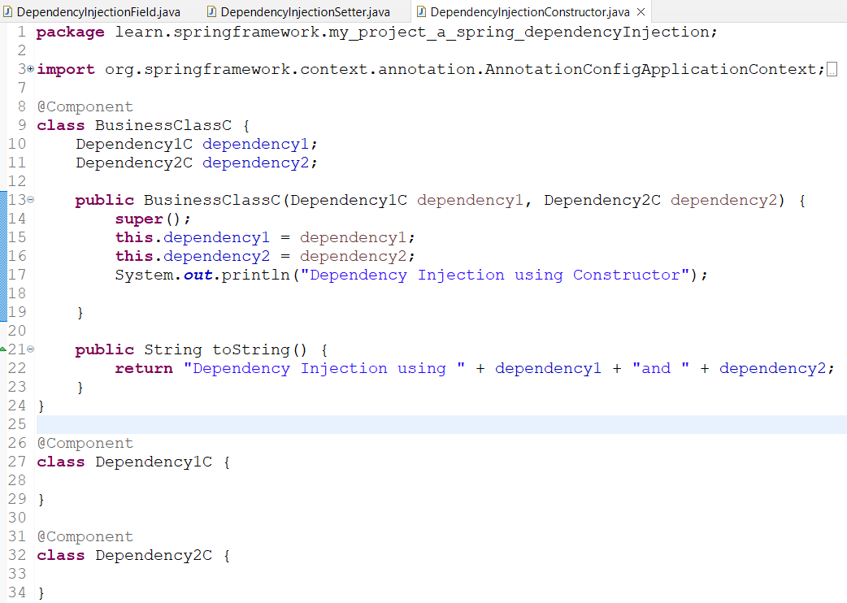
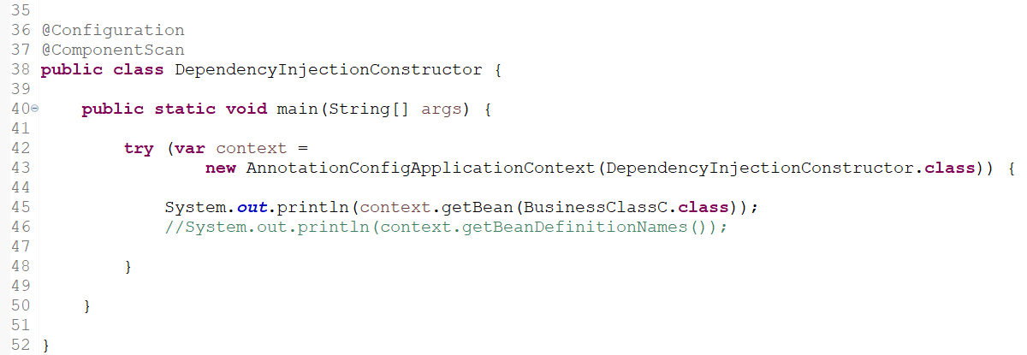

Note:
- It is always recommended by Spring to use Constructors based Dependency Injection as dependencies are automatically set when an Object is created.
- All the initialization happened under a single method. Once initialization is done, the Bean will be ready for use.
- @Autowired Annotation is not mandatory in this case.

Step-05: Understanding Important Terminology related to Spring Framework
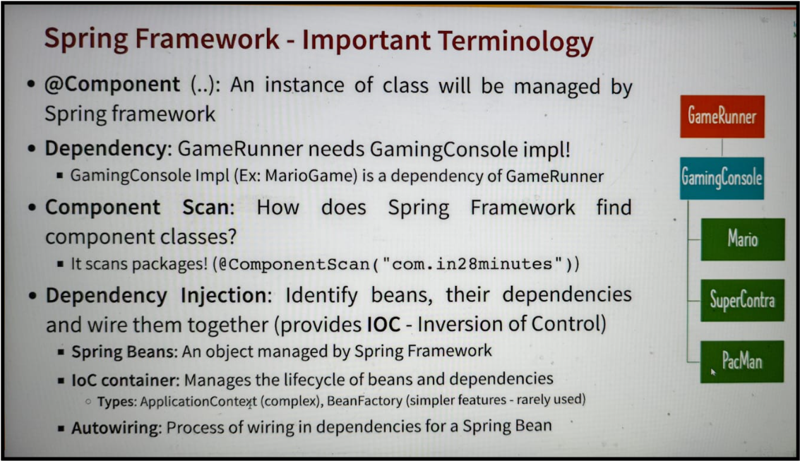

- @Component ( .. ): An instance of class will be managed by Spring framework.

- Dependency: GameRunner needs GamingConsole impl!
· GamingConsole Impl (Ex: MarioGame) is a dependency of GameRunner

- Component Scan:
How does Spring Framework find component classes?
It scans packages! (@ComponentScan("com.in28minutes"))

- Dependency Injection
Identify beans, their dependencies and wire them together (provides IOC - Inversion of Control)

- Spring Beans: An object managed by Spring Framework

- loC container: Manages the lifecycle of beans and dependencies

  - Types: ApplicationContext (complex), BeanFactory (simpler features - rarely used)

- Autowiring: Process of wiring in dependencies for a Spring Bean

Step-06: Comparison : @Component vs @Bean

Heading | @Component | @Bean
Where to use it? | Can be used on any Java class | Typically used on methods in Spring Configuration
Ease of use | Very easy, just by adding an annotation. | You write all the code.
AutoWiring | Done using Field, Setter or Constructor Injection | Done using method call or method parameters
Who creates Beans? | Spring Framework | We write bean creation code
Recommended for | Instantiating Beans for our Own Application Code: @Component | 1:Custom Business Logic  2: Instantiating Beans for 3rd-party  libraries: @Bean

Step-07: Why do we have Dependencies in Java Spring Applications?

For small applications like - the gaming application we developed, have only a few of the classes(Eg: Mario, Packman, SuperContra on which the GameRunner class was dependent.

But for Business Applications, there will be several classes on which there will be several dependencies & to avoid the complexity in managing manually created Beans, Dependency Injection & Wiring, we need Spring Framework to handle these for us.

This will help us to focus only on the Business Logics.

Step-08: Example: Solution for Real World Java Spring Framework Example

Let’s build a simple Business Application where there are following classes:
- Web Application: this is a Launcher for the Business Application
- Business Calculation Service: This will perform the Business computations
- Data Service: A Database Service interface implemented by the specific DB services like MongoDb & MySQL.
- MongoDbDataService & MySQLDataService: This will directly communicate with the DB to manage the data.
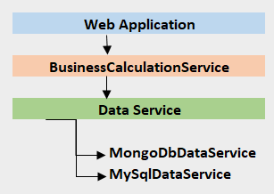

DataService Interface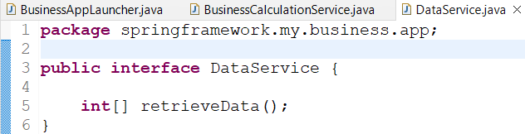

MySQLDataService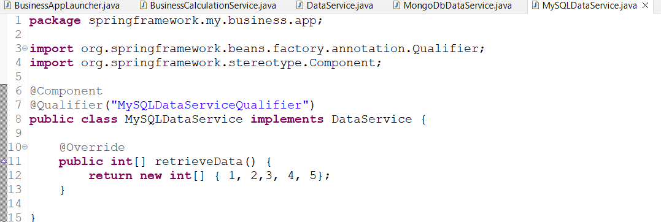

This is a SQL Database Service which implements Database Service.
It communicates with the database to manage/maintain/get the data required for the Business Calculations

MongoDbDataService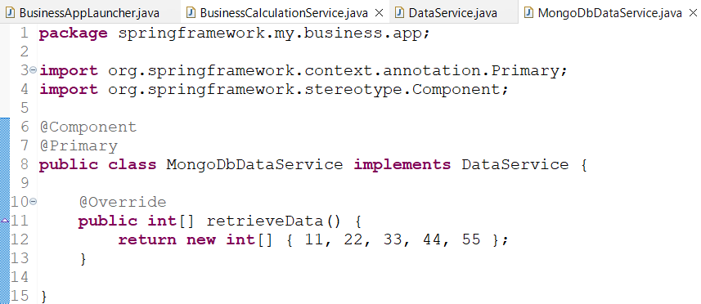

This is a SQL Database Service which implements Database Service.
It communicates with the database to manage/maintain/get the data required for the Business Calculations

BusinessCalculationService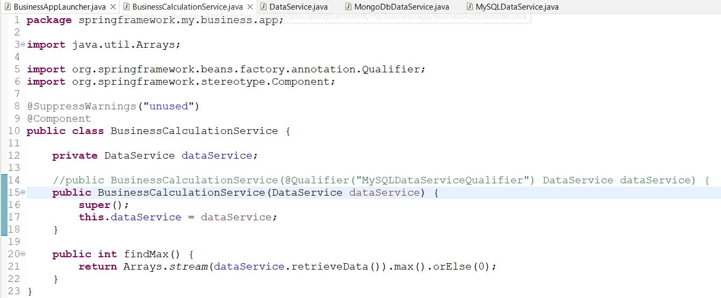

BusinessAppLauncher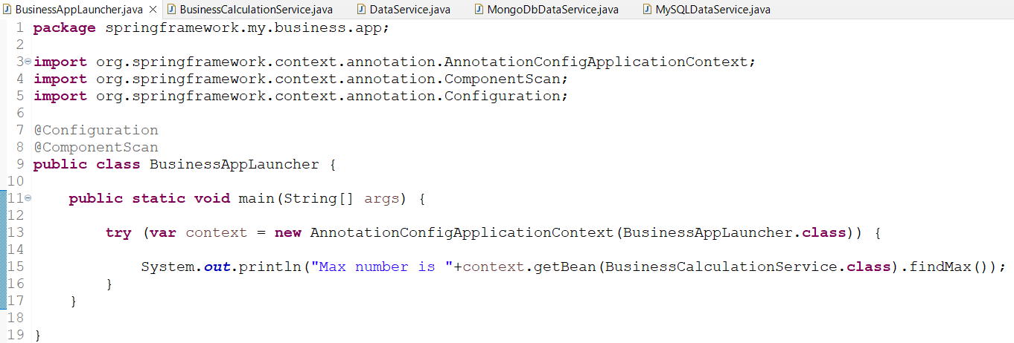

Output:

Since we have 2 instances of the DataService (one for MongoDB & another for SQL DB) where MongoDB is annotated as Primary, so the Business results will be returned through the MongoDB

Further we can use the @Qualifier Annotation to specify SQL DB specific Object & inject as a dependency to the Business Calculation Service.
Then the SQL DB object will be injected & Business calculations will be driven through the SQL DB.
